Valuable Tricks to improve website traffic

Every business owner likes increased traffic to their website. More traffic can generate more leads, increase conversions, and get more customers. There are many ways to increase traffic on the website.

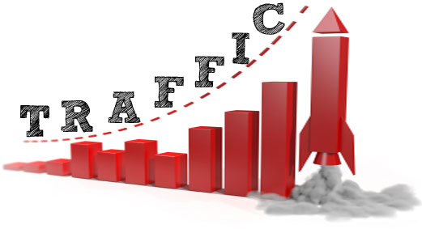

* **Advertise**- Paid advertising, Social media advertising, display advertising are effective ways to increase traffic on the website. It attracts customers. Just build your brand and getting your site in front of people. Adword India is a [PPC advertising agency](http://adwordindia.in/). Shopping ads on Google, Facebook advertising, Google ads, PPC ads on Google are the paid ways of advertising.
* **Use social media channels**- Use of social media channels is the best way to increase traffic on the website. Facebook, Youtube, Twitter, Instagram, Pinterest, etc are the social media channels. Social media channels cover all type of age group users. Marketers consider that social media channels are an effective way to reach the audience.
* **Target long-tail keywords**- There are many free tools available to help you find keywords to target. Targeting long-tail keywords give a better chance of ranking higher for queries specific to products or services. A higher ranking means more traffic.
* **Create a GMB (Google my business) listing**- Optimized GMB listing gets more visitors. Don't forget to list links to the website. It is a great way to get more traffic to your website. Google listing is getting smarter and smarter with results.
* **SEO on-page and off-page activities**- There are many SEO tactics you can perform on each of the website pages to increase their rank in SERP. It can increase more visitors. On-page activity includes producing high-quality content and writing a concise Meta Title, description for a page. The off-page activity includes backlinks. A backlink is a link to your website from another website.
* **E-mail marketing**- Email marketing is one of the only marketing channels you can have complete control over. With Email marketing, you’ll be able to keep driving website traffic to your store as long as customers stay subscribed.
* **Post content to Linkedin-** Your Linkedin profile is the first impression on the site so make it a good one. The world’s largest professional Social network “Linkedin” is currently a valuable business enterprise platform. You can post content to Linkedin on a regular basis. It can boost traffic to your site, as well as increase your profile within your industry If you have a moderately large following on Linkedin.
* **Guest post**- There are two ways of guest posting- You can submit a post to other sites or you can accept a post from external contributors. Search for high DA guest posting websites and post to those websites. Some websites have submission guidelines, so it is important to check that first.
* **Presence of social channels buttons on a website**- Add social channels button to shareable pages like blog, product pages, and other website content pages. These social channels buttons give proof of the social presence. Social presence increases website traffic.

Adword India helps brands, business and individuals to make them recognized. It boosts brand presence with effective marketing strategies and unique techniques. The best **PPC advertising agency** is Adword India. Furthermore information visit - [https://www.adwordindia.in/](https://www.adwordindia.in/how-to-increase-website-traffic-through-google/)